How to use ConnectWise .Net SDK:

1. In Visual Studio > Solution Explorer, right click References and select “Add Reference…”

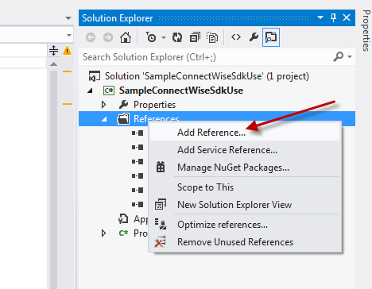

1. Click “Browse…”

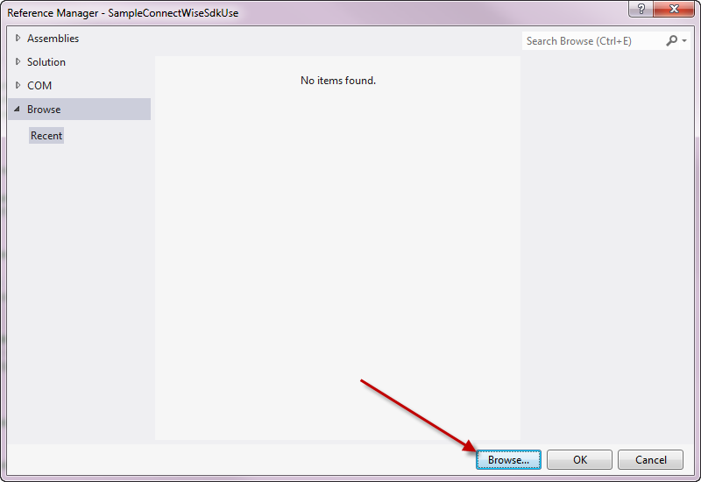

1. Locate the unzipped “ConnectWiseSDK” folder and select “ConnectWiseSDK.dll”, click “Add”

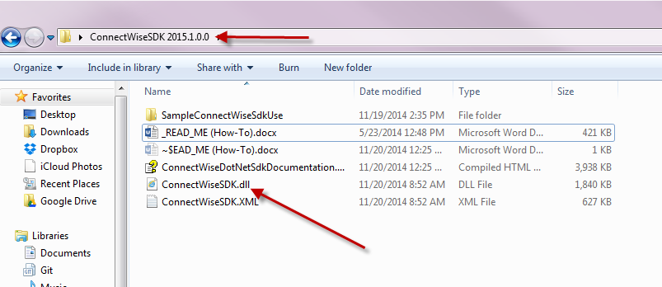

1. Click “OK”

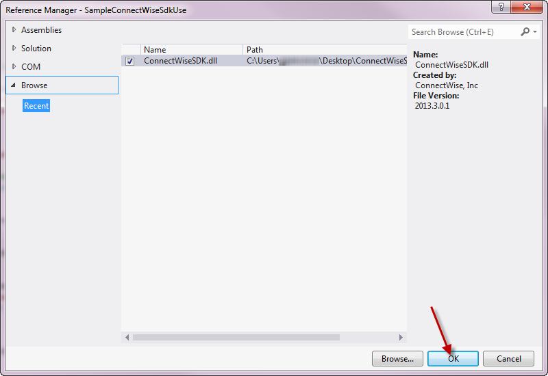

1. Add “using ConnectWiseSDK;” to your code

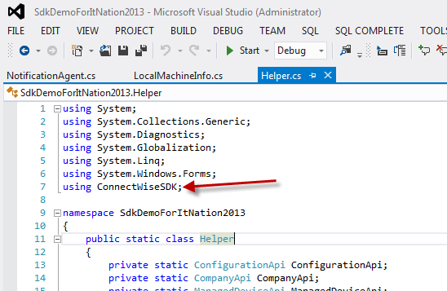

1. For assistance on classes, methods, etc.; please reference “ConnectWiseDotNetDocumentation.chm”

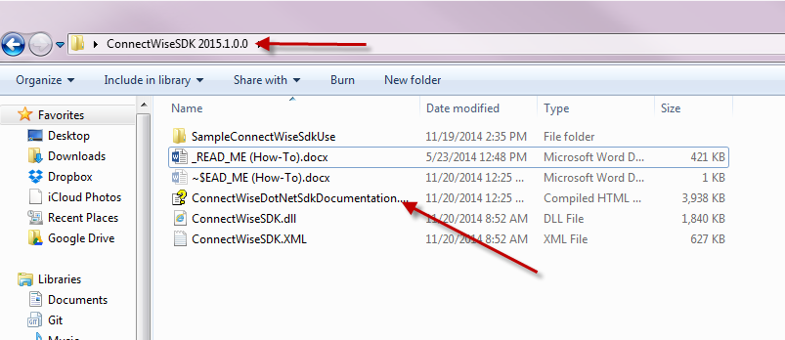

1. Happy Coding! ☺ See sample application in same folder where SDK was unzipped

